Antonio E. Ramirez

15 December 2019

Final Project

CMSC 412

# Introduction

For this project, we were asked to implement a console-based program that will simulate various page replacement algorithms. These algorithms included: FIFO, OPT, LRU, and LFU. It also should allow for user input reference strings and randomly generated reference strings. This was an interesting project that implemented concepts from the readings.

# Implementation

I was able to break the implementation of this project down into 3 classes. The first was the main class. This class contained the main method, which displayed the menu within a while loop. The only way this loop is exited, is by using the appropriate menu option. This class also contained methods for the creation of the reference strings. Both the autogenerated and user-input strings included the necessary checks to ensure the strings conform to the project parameters.

The next class is the Frame class. This class was used to effectively track the different aspects of the individual frames. This allowed each frame to be an instance of the class, and made tracking usage, such as frequency, much easier. While there are other methods to handle this, such as separate hash maps for each statistic, I found that the Frame class made this much easier and less confusing. This class is the smallest, essentially just setters and getters of the class fields. However, it prevented a lot of duplication of code, and made the code much more readable.

The last class was the MemorySim class. This class contains all the methods to run the selected algorithms. An instance of this class is used within the main method, to run the necessary class methods within the main switch. This class also contains a method to display the results of the algorithms to the console. This class relies heavily on various arrays to keep track of the frames and how they were used.

# Screenshots

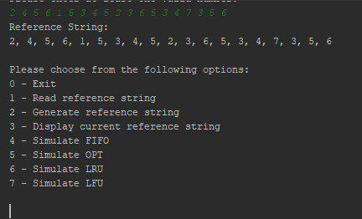

Showing the reference string from homework 6 has been entered

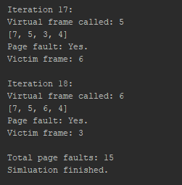

Shows the completion of FIFO simulation.

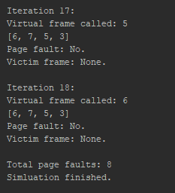

Shows the completion of OPT simulation.

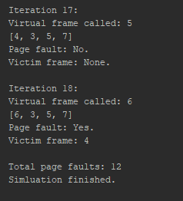

Shows the completion of LRU simulation.

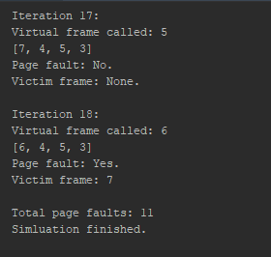

Shows the completion of LFU simulation.

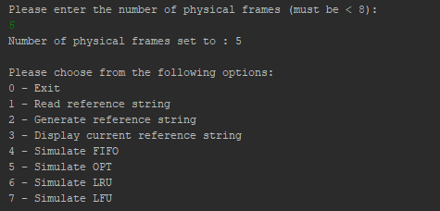

Setting n=5.

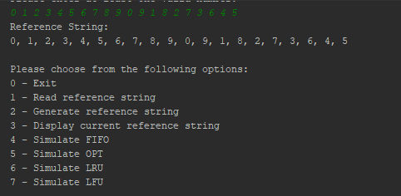

Showing the reference string from the rubric has been loaded.

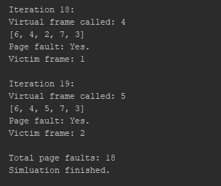

FIFO

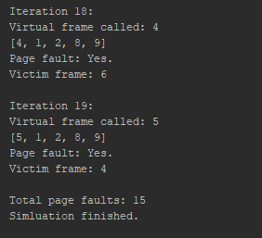

OPT

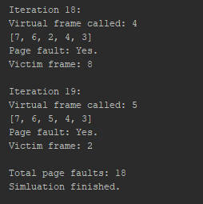

LRU

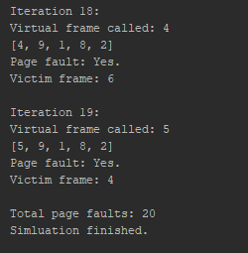

LFU